Workers’ Compensation Guide For FMS
- As soon as an employee reports a job-related injury or illness, you must print out the Mains’l Claim Packet and fill in the Claim Information Report within 24 hours of injury. Fill in as much information as possible and email or fax to WCMC. You may also file a claim information report electronically at https://wcmcforms.com/ . Please inform your Mains’l FEA manager of the injury as well.
  - Contact information: Fax 651-501-1493 or Email claims@wcmcinc.com

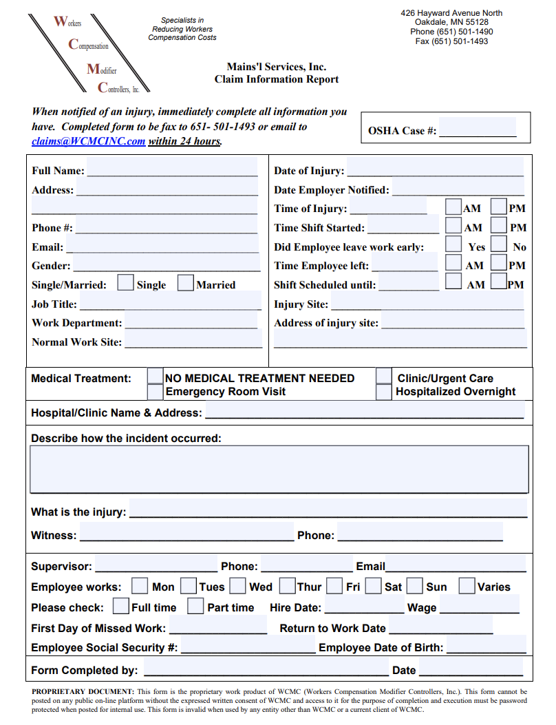

- Provide the employee with the Workers’ Compensation Claim Form (DWC1), Physical Restricitons Form, and inurance information page to take with them to an in-network WCMC provider to be evaluated to be evaluated. To find in network providers in your area, please visit https://accidentfund.com/california-medical-provider-search/. The injured employee will need to fill out the top section of this form labeled “Employee.“

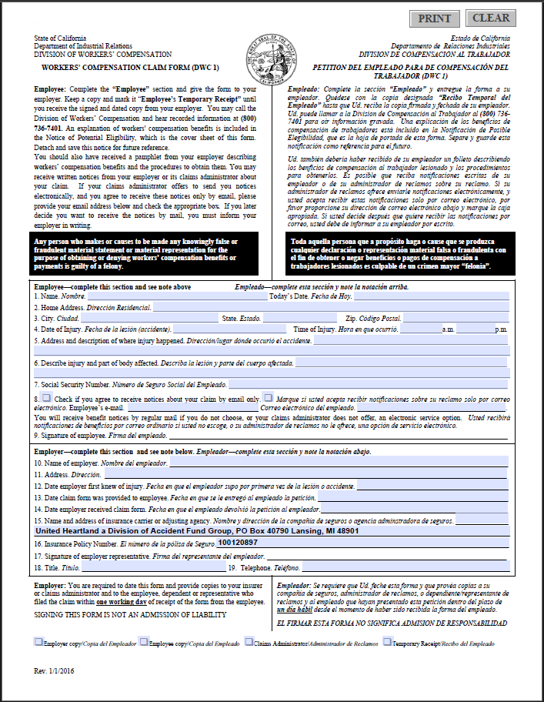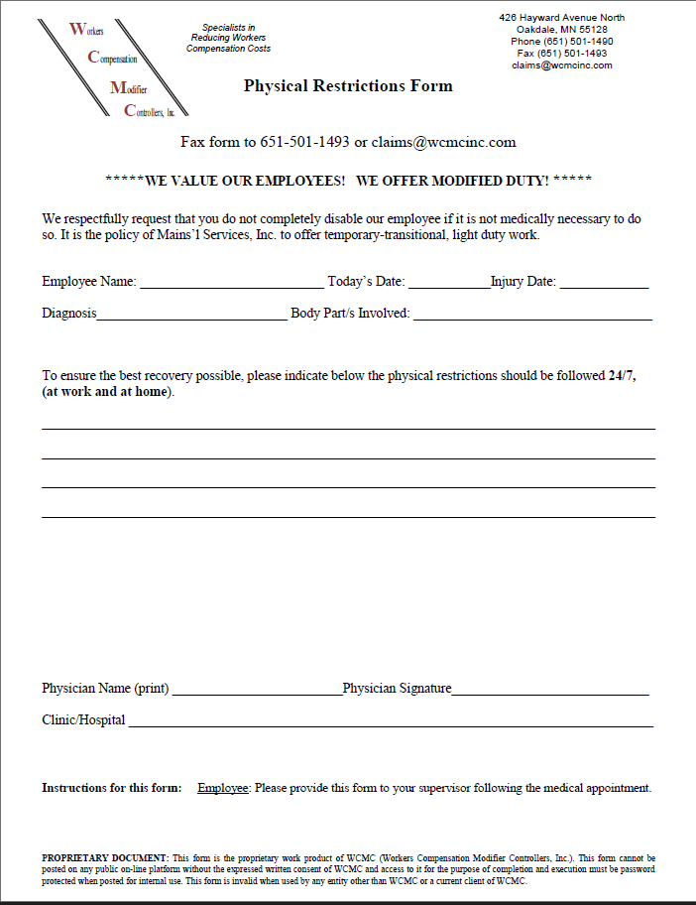
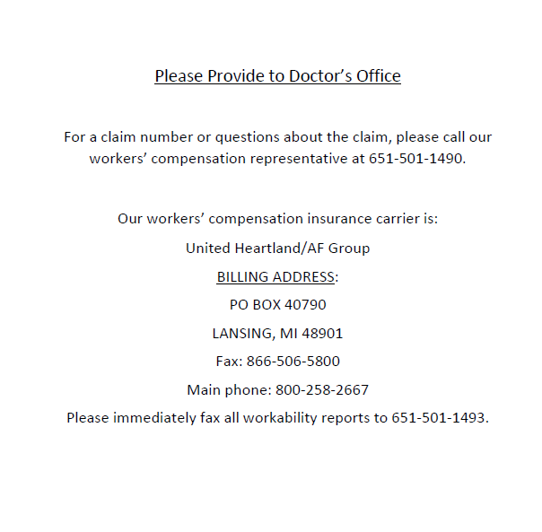

- After the employee has been evaluated by the doctor, ask them to complete the “Employee’s Description of Injury” portion of the Mains’l Claim Packet. They will need to describe their injury completely including every part of the body on the body diagram and sign and date authorization forms. Once this is completed, send the DWC1 and the complete Claim Packet your Mains’l FEA manager.

